Abstract
Systems for automatic speech verification are being used more than ever for security-sensitive use cases like biometric authentication, access control, and identity verification remotely. Although machine-learning-based approaches have improved the capabilities of these types of systems to detect types of spoofing, research shows that they are still very vulnerable to adversarial attacks in which small, intentionally designed modifications to an audio recording can cause the system to misclassify what it hears. Most research on the robustness of systems against adversarial attacks has focused on convolutional neural networks (CNNs); however, there has been limited research on lightweight countermeasures for spoofing, which typically use less computational power and memory and will be deployed in resource-constrained environments. This thesis proposes a lightweight log-mel-based feed-forward neural network can withstand adversarial attacks on its ability to identify synthetic audio recordings. The network was tested against the white-box Fast Gradient Sign Method (FGSM) and Projected Gradient Descent (PGD) adversarial attack algorithms, and its performance was compared to a traditional CNN-based spoofing countermeasure that was developed to perform the same task. Experiments to evaluate the network's vulnerability to these types of attacks were performed with the structured ASVspoof2019 LA dataset and an unconstrained real-world WILD dataset. Results indicate that while the lightweight feed-forward network had strong baseline performance, it suffered from even greater impairments than traditional CNN-based spoofing countermeasures when subjected to adversarially-created noise. Therefore, even when a countermeasure has high classification accuracy, it does not guarantee that the system can detect synthetic audio recordings under all conditions, and when designing deployable ASV countermeasures, it is imperative to conduct adversarial-aware evaluations.

1 Introduction
Automatic Speaker Verification (ASV) refers to an electronic method of authentication which utilizes unique features of an individual’s vocalization as a source of recognition. ASV has gained traction due to its simplicity of use and accessibility for individuals who wish to authenticate themselves via ASV while located remotely. As a result of the growing adoption of ASV technology across multiple industry segments including banking, smart home devices and access control systems; lot of companies are beginning to feel threatened by the rise in ASV systems that many companies are developing.
One of the most dangerous threats to ASV systems is a form of spoofing, which takes the form of individuals using replays of recordings, synthetic speech or techniques such as voice conversion to impersonate a legitimate user. As a result of this challenge, researchers have developed tools to determine whether a voice signal is genuine or has been spoofed. Recent advancements in machine learning have increased the accuracy of spoof detection methods, however, growing evidence suggests that many of these methods are vulnerable to being fooled through the use of adversarial techniques. This research aims to identify these vulnerabilities, focusing specifically on the use of lightweight methods for spoof detection and comparing these to more complex models that are based on deeper neural networks.

Automatic Speaker Verification (ASV) Systems are used as a biometric Authentication system for end-users because it provides Non-Invasive Authentication to users; they are easy to use and can be implemented via an ASV system or a Telephone Banking Service, etc. However, ASV systems are susceptible to attack due to Spoofing attacks where an individual attempts to gain unauthorised access by deceiving an ASV system with either Replayed, Synthesised or Converted speech. Benchmark tests and surveys of ASV systems conducted over the past few years have shown that Spoofing will continue to pose a problem for ASV systems and that Spoofing can be difficult to detect and combat with new detection methods available (Cai 2017; Kinnunen & Sahidullah 2017).

To combat the threats of Spoofing in ASV Systems, there are a variety of Countermeasures available; most proposed Countermeasures are based on Machine Learning models using Spectral Representations of speech, mainly Log-Mel Spectrograms. Although it is factors have a large number of different types, the accuracy of many Machine Learning Methods tested on Benchmark Datasets has been shown to be very high, the growing concerns about how Robust these methods are against Adversarial Conditions has been raised, the most recent research suggests the Countermeasures may be Manipulated by creating Adversarial Perturbations in the input to the Countermeasures to cause Misclassification of input (Liu et al 2019).

Adversarial Machine Learning and audio-based biometric systems introduce a very real threat model for ASV systems. In particular, gradient-based attacks such as the Fast Gradient Sign Method (FGSM) and Projected Gradient Descent (PGD) use the sensitivity of neural networks to input perturbations that create a maximum classification loss (Goodfellow et al. 2015; Madry et al. 2018). These attacks have been shown to have a dramatic effect on the performance of all ASV systems, even when the perturbations are not perceptually obvious.
Adversarial attacks in ASV are particularly worrisome due to the impact of these types of attacks being an increase in the false acceptance rate (FAR) as fake (spoof) audio is misclassified as real. Liu et al. (2019) report that multiple state-of-the-art convolutional neural network (CNN) based countermeasures have suffered from disastrous performance losses under FGSM and PGD attacks. Other researchers have also confirmed that adversarial vulnerability appears to be a widespread issue across ASV architectures and feature representations (Wu et al. 2020).
Most studies on adversarial robustness in ASV focus on deep convolutional neural networks (CNNs) tested against structured datasets like ASVspoof2019 LA. These datasets are necessary for testing under a controlled environment but do not represent all the variations of audio that can be found in the real world (Kinnunen & Sahidullah, 2017). Furthermore, deep models place a higher demand on computational resources than lightweight models, which may limit their use in the real-world environment where lightweight and efficient systems are preferred.

Light-weight spoofing countermeasures are typically based on basic feed-forward networks and spectral features, therefore making them suitable for various resource-limited settings. Yet, research about how resistant to adversarial attacks the lightweight spoofing countermeasures are is limited. Additionally, the question remains whether an increase in model complexity will increase resistance against adversarial alteration or if the current adversarial vulnerability of learning-based countermeasures is a basic characteristic of these systems (Wu et al., 2020; Wu et al., 2022).

This thesis focuses on white-box adversarial attacks applied at the feature level. Experiments are conducted on the ASVspoof2019 LA dataset and a real-world WILD dataset to assess dataset-dependent vulnerability. The key contributions of this work are:
- An adversarial robustness evaluation of a lightweight spoofing countermeasure
- A comparative analysis between lightweight and CNN-based models
- A dataset-level comparison highlighting differences between benchmark and real-world conditions
- Empirical evidence supporting prior findings on the fragility of spoofing countermeasures under adversarial attacks (Liu et al., 2019; Wu et al., 2020)
On a whole, this work extends prior adversarial robustness studies by evaluating lightweight spoofing countermeasures alongside reproduced CNN-based models across both benchmark and real-world datasets, demonstrating that adversarial vulnerability is a systemic challenge independent of model complexity.
2 Literature Review
Automatic Speaker Verification (ASV) systems have been identified as susceptible to being spoofed using recently developed applications in speech synthesis, voice conversion and replay attacks (Kinnunen and Sahidullah 2017). The traditional countermeasures were based on handcrafted features and shallow classifiers, while these systems had difficulty generalising to a variety of different types of spoofing. The ASVspoof challenges demonstrated the limitations of these countermeasures, leading to the development of enhanced anti-spoofing technologies based on deep learning.
In recent years a new form of intelligent systems has emerged that utilizes deep learning in its entirety. These systems include a growing number of convolutional neural network (CNN) architectures and deep learning algorithms based on spectral information. For instance, Salih et al., 2025 have demonstrated the effectiveness of using CNN trained on the spectrogram and mel frequencies to detect spoofing attacks within automatic speaker verification systems (ASV). CNN architectures such as LCNN-big, LCNN-small, and SENet12 form the foundation of many ASVspoof systems.
However, the strength of these deep models is counterbalanced by three issues:
- Overfitting to dataset-specific artefacts, limiting generalisation.
- High computational cost, making them unsuitable for low-resource deployments.
- Documented fragility to adversarial perturbations, which dramatically distort performance.
The work of Liu, Wu, Lee, and Meng (2019) determined that many speech-processing models' inherent security issues had been demonstrated by the significant vulnerabilities of adversarial ML identified in their study. The study also demonstrated that while CNNs perform well, when tested using FGSM and PGD techniques, they resulted in the destruction of the performance of the spoofing countermeasures, even at very low perturbation levels. The study presents the first systematic evidence that many high-performing anti-spoofing systems are not guaranteed to be inherently secure.
Recent studies have validated and further developed this list of vulnerabilities through the study of the two attack categories of white-box and transfer attacks (Wu et al., 2020). Their study confirmed that across all types of speech-processing systems, adversarial perturbations were effective when applied to all architectures, and as shown, did not increase as the model became more complex; thus, modelling deeper neural networks was not related to guarantee higher levels of adversarial robustness (Kassis & Hengartner, 2021).
More advanced methodologies have emerged for creating adversarial attacks, including "Malafide", a universal connotative noise attack introduced by Panariello et al. (2023) that does not require access to gradient maps of utterances; therefore, it is effective against any style of utterance. As demonstrated by Kassis and Hengartner (2021), adversarial perturbations created based upon physical-world sounds can also be created in real-time, enabling practical attack scenarios that are not limited to controlled/laboratory environments.
These studies underscore that adversarial attacks represent a realistic and highly feasible threat to ASV systems.
Defences against adversarial attacks typically fall into two categories:
Wu et al. (2020) showed that adversarial training can improve robustness but is computationally expensive and may reduce clean-speech performance.
Although less robust than many other more sophisticated and heavier gradient descent approaches, the aforementioned mitigation techniques still offer some level of protection against weaker attacks through their use of self-supervised feature learning (Wu et al., 2022). In addition to employing large amounts of compute to train and evaluate their performance, self-supervised feature learning techniques do not yet offer a pathway towards studying lighter systems.
Khan, Malik & Ryan (2022) describe how lightweight models based on log-mel or cepstral features, combined with Multi-Layer Perceptrons (MLPs) or other low complexity architectures (in terms of depth), are commonly used due to their fast processing times and low power consumption. While many lightweight models exist, very few have been assessed for their resilience to adversarial attack. There is reason to believe that, because of the lower complexity of these models (i.e., less complex decision boundaries) and limited representations of their inputs, these models may have lower resistance to adversarial attacks than CNNs but this has yet to be confirmed; thus representing an important area requiring further investigation.
Modern adversarial attacks increasingly account for real-world constraints:
- Universal filters (Panariello et al., 2023) require no per-sample optimisation.
- Time-domain perturbations (Kassis & Hengartner, 2021) make physical deployment feasible.
- Perturbation transferability enables black-box attacks without model access.
These developments show that adversarial threats are no longer theoretical—they can be deployed practically against real ASV systems. This further amplifies the need to understand the vulnerabilities of lightweight models.
Across the reviewed literature, several critical gaps emerge:
- Lightweight log-mel–based models remain untested against adversarial attacks, despite being common in deployed ASV systems.
- Most studies evaluate robustness only on structured datasets, neglecting real-world acoustic variability.
- Comparative robustness between lightweight and deep models is unknown.
- Existing defences focus primarily on CNNs, offering no guidance for resource-constrained environments.
Our study provides a contribution towards filling these gaps in knowledge pertaining to adversarial robustness, with (a) performance of the lightweight MLP model and strong adversarial attacks, (b) comparisons between the MLP and CNNs trained on ASVspoof and WILD datasets, and (c) evaluations of CNN models that have been reproduced and benchmarked against Liu et al.'s (2019) CNN models.
The purpose of this section is, therefore, to synthesize the main outputs that were generated during the execution of this project, output such as prepared datasets for experimentation, implemented models, adversarial attack mechanisms, evaluation artefacts, and analytical results. Each output strongly channels some of the common developments of the research objectives stated in the previous sections.
4.1 Summary of Project Outputs
Output Name | Type | Description | Primary Purpose
ASVspoof2019 LA Processed Dataset | Dataset | Structured dataset prepared using official protocol files, containing labelled bona fide and spoofed samples with extracted spectral features. | Baseline and adversarial evaluation on a benchmark dataset
WILD Processed Dataset | Dataset | Real-world audio dataset processed into log-mel representations with consistent formatting and normalisation. | Evaluation under unconstrained, real-world conditions
Lightweight Log-Mel MLP Model | Model | Feed-forward neural network trained on flattened log-mel spectrogram features for spoofing detection. | Primary model under adversarial evaluation
Reproduced CNN Countermeasure Models | Model | Reimplementation of CNN-based spoofing countermeasures following Liu et al. (2019). | Comparative robustness benchmarking
FGSM Attack Module | Algorithm / Code | Implementation of Fast Gradient Sign Method for generating adversarial examples. | Evaluation of first-order adversarial vulnerability
PGD Attack Module | Algorithm / Code | Iterative Projected Gradient Descent attack with configurable parameters. | Evaluation under strong adversarial conditions
Evaluation and Metrics Framework | Tool | Scripts to compute accuracy, FAR, FRR, EER, and attack success rate on clean and adversarial inputs. | Quantitative performance assessment
Visual Analysis Outputs | Figures | Confusion matrices, performance degradation plots, and comparative charts. | Interpretation and presentation of results
5 Methodology
The framework for determining the ability of spoofing countermeasures to withstand adversarial attacks is described in this section. Specifically, it explains how datasets are prepared, features are extracted, models are built, adversarial attacks are generated and tests performed on the resulting models. Additionally, this framework has been developed to ensure that any model developed can be reproduced and provides parity with respect to lightweight models and CNN models when using different datasets.
5.1 Experimental Workflow Overview
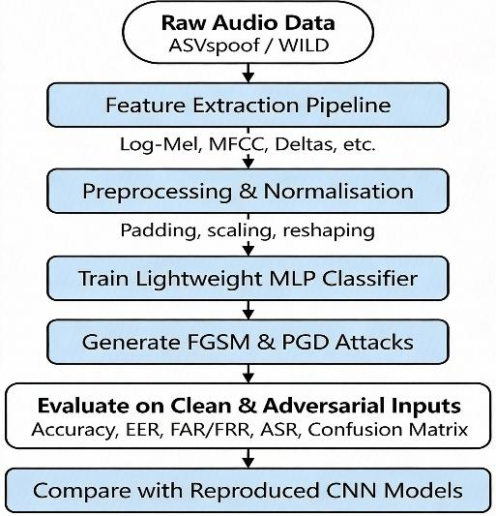
The linear and modular approach of the experiment workflow consists of the following steps: The Audio data collected and converted to the spectral feature domain; Models trained to analyse audio data in clean condition, then evaluated under a selection of adversarial conditions using gradient based attacks; The evaluation performance will be measured with both traditional classification metrics (accuracy, precision, recall, and F1 score) and also with ASV specific security metrics.

The same preprocessing and evaluation procedures are applied across datasets and models to ensure consistency and comparability.
5.2 Datasets
5.2.1 ASVspoof2019 LA Dataset
The ASVspoof2019 Logical Access (LA) Dataset represents the core reference dataset for this investigation. This dataset contains both legitimate and artificially generated deceptive speech produced utilizing numerous methods for voice synthesis (text-to-speech) and modification (voice conversion) (Kinnunen & Sahidullah, 2017). Furthermore, the ASVspoof2019 LA Dataset supplies protocol files that identify how to allocate the training/development/evaluation data, with strict adherence to these documents in this investigation.
5.2.2 WILD Dataset
A WILD dataset uses real-world scenarios in addition to the benchmark evaluations to evaluate how well various systems (i.e., voice recorder apps) will work in an unconstrained environment. The main difference between ASVspoof and WILD is that ASVspoof provides strict controlled conditions under which recordings should be made; whereas WILD provides recordings made in a variety of environments with different levels of ambient noise, recording devices and various acoustic properties. As WILD does not impose conditions on the generation of recordings, it allows for the evaluation of generalization to "real-world" scenarios.
5.3 Feature Extraction and Preprocessing
All audio samples are converted into log-mel spectrogram representations, which are widely used in spoofing detection due to their efficiency and strong discriminative capability.
The preprocessing pipeline includes:
- Audio loading and resampling to a consistent sampling rate
- Log-mel spectrogram computation
- Padding or truncation to ensure fixed-length representations
- Feature normalisation using training-set statistics
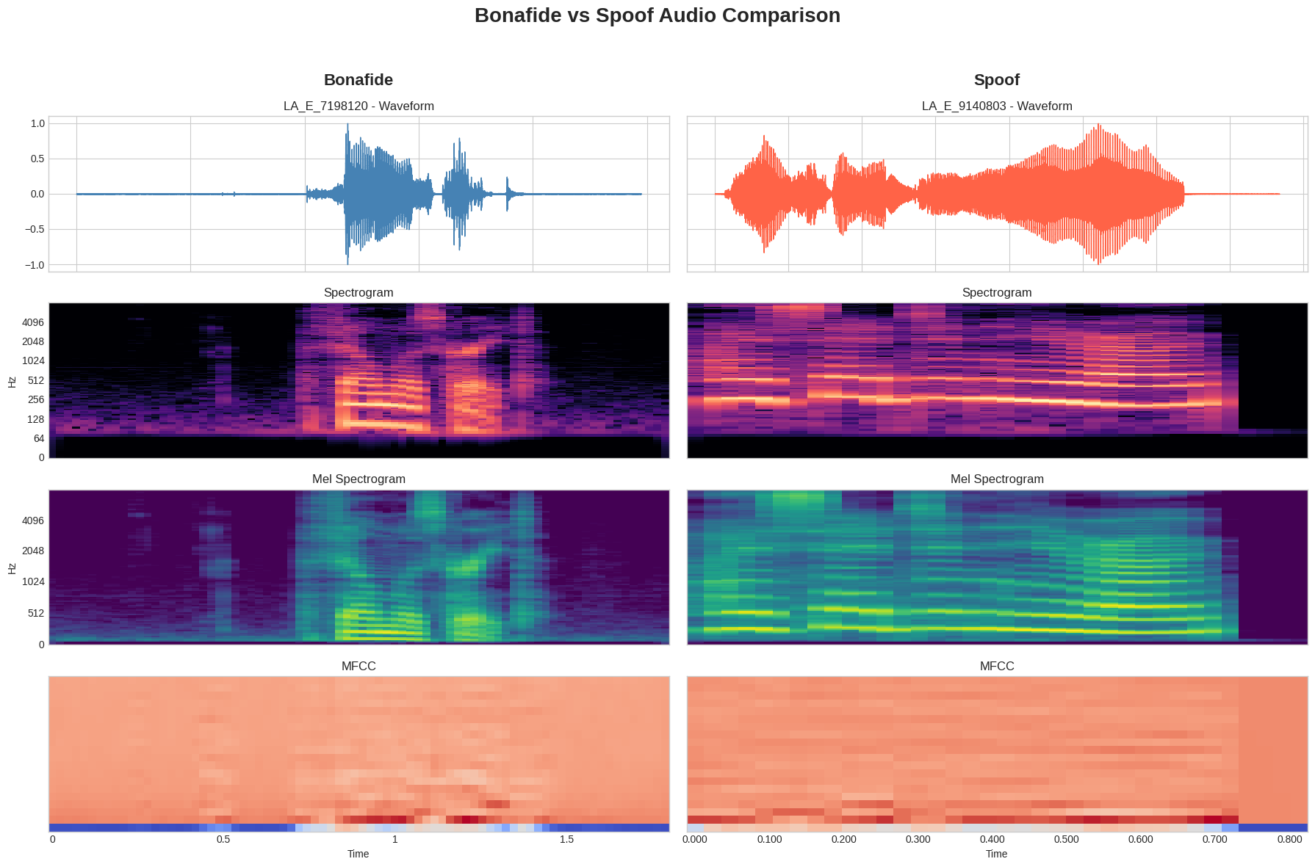
These steps ensure uniform input dimensions and stable training behaviour across both datasets.
5.4 Model Architectures
5.4.1 Lightweight Spoofing Countermeasure
The lightweight feed-forward neural network was the major model used to create the result described in this paper. This was made up of a flattened log-mel spectrogram input feature, hidden layer(s) consisting of non-linear activation, and a sigmoid classification output (for treatment of binary issues).
The selection of this model was based on the fact that this type of model is representative of many different types of spoof countermeasures that can be used when there are strict limitations on hardware resources and low latency performance.
5.4.2 CNN-Based Countermeasures
This provides an opportunity for comparison of CNN Spoof Measurements to a benchmark. In order to do this, the same architectures that Liu et al. (2019) assessed using the Spectro Temporally based architecture, which receives a Spectro-temporal representation and then uses a convolutional layer for capturing localized Acoustic Patterns, were used to produce CNN Spoof Measurements. By reproducing these models, a valid comparison of the results produced by the Light Weight model and the Deep Learning (DL) model can occur, in the same adversarial conditions used in Liu et al. (2019).
5.5 Adversarial Attack Methods
Adversarial robustness is evaluated using two white-box gradient-based attacks.
5.5.1 Fast Gradient Sign Method (FGSM)
The FGSM method is one of the easiest and quickest methods to create an adversarial sample with just one step using a gradient-based approach to calculate small amounts of noise added to the input image in the opposite direction of the gradient of the loss function for that image (Goodfellow et al, 2015). The amount of noise added is proportional to a user's specified amount ε (the attack budget for the perturbation). Using the FGSM method will allow an individual to create an adversarial sample and quickly evaluate how susceptible an object is to producing such samples.
5.5.2 Projected Gradient Descent (PGD)
PGD is an iterative extension of FGSM that applies multiple small gradient steps while projecting the perturbed input back into an ε-bounded region around the original sample (Madry et al., 2018). PGD is considered a strong adversary and is used to evaluate worst-case robustness.
Both attacks are applied at the feature level and evaluated across a range of ε values to observe performance degradation trends.
5.6 Evaluation Metrics
Model performance is evaluated on both clean and adversarial data using the following metrics:
- Accuracy
- False Acceptance Rate (FAR)
- False Rejection Rate (FRR)
- Equal Error Rate (EER)
- Attack Success Rate (ASR)
These metrics are widely used in ASV security research and provide insight into both classification performance and security risk (Liu et al., 2019).
5.7 Experimental Protocol
Adversarial attacks are used to form a baseline against which to evaluate a machine-learning model's performance. Models are built, trained, and validated against clean datasets to determine their initial baseline performance. Adversarial examples (as either FGSM or PGD-style inputs) are then produced based on a trained machine-learning model without any algorithmic re-training of the model, thereby isolating attack-induced performance degradation attributable solely to the attacks. This test protocol is followed uniformly for other datasets/models to permit equitable comparison of results.
5.8 Summary
The methodology is a methodical process to quantify the adversarial robustness of anti-spoofing countermeasure systems. It utilizes Binary Benchmark and real-world datasets as well as shallow (lightweight) and deep learning model architectures (strong models), and weak (low-level) and strong (high-level) adversarial attacks to provide an opportunity to fully evaluate model vulnerabilities against realistic threat scenarios.
6 Design Specification
In this portion of the article you will find an overview of how to create a framework for testing how Well prepared are the Countermeasures against spoofing attacks

With respect to Designing a framework for assessing adversarially robust systems. The Framework allows for Modularity, Flexibility, and Opportunities for Fair & Valid Reproducible Testing Comparisons Between Models, Datasets, and Methods.

6.1 System Architecture Overview
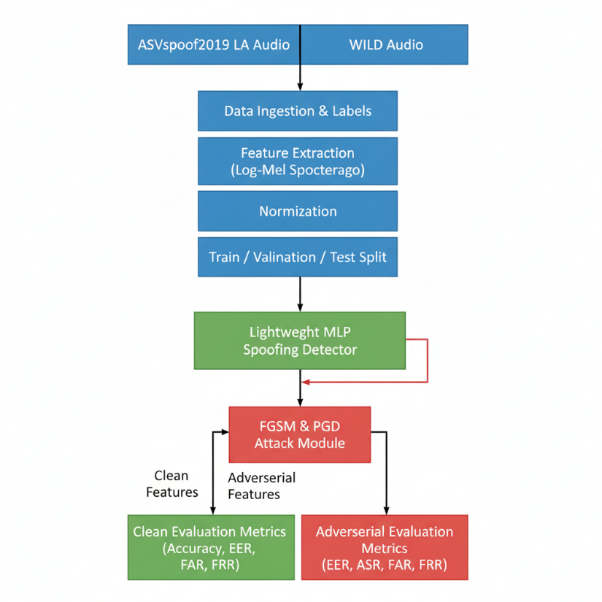
The overall system architecture follows a modular pipeline consisting of five core components:

This separation of components ensures clarity, reusability, and flexibility, allowing individual modules to be modified or extended without affecting the overall system.
6.2 Data and Feature Design
Two datasets have been chosen as a representative correlation between the system of records: the benchmark data sets are ASVspoof2019 LA, and WILD, which contains all of the required dataset protocols (Kinnunen & Sahidullah, 2017), that conform to the stringent benchmark specifications recommended by the ASVspoof Project. The WILD dataset also provides metadata that is formatted according to the end-users definition of a metadata structure, providing a method to have consistent labelling and retrieval of records.

Log-Mel spectrograms will be used for the feature representation of audio data since log-mel spectrograms are computationally cheap and as such are widely used within audio data processing systems for detecting the existence of spoofed audio. Consequently, a fixed length feature representation will be produced from the recorded audio spectrogram by either padding or truncating the input spectrogram. This fixed-length vector will ensure that both the lightweight architectures and convolutional neural networks (CNNs) have a common representation. The statistics derived from the training datasets used to compute the features were also incorporated into the design of the entire system to support stable and reliable learning and evaluation of all components of the system.
6.3 Model Design
6.3.1 Lightweight Spoofing Countermeasure
A lightweight Countermeasure/approach based on a feed-forward Neural Network has been designed to use Event-emerging features obtained from flattening log-mel Features' representations (Flattened Log-Mel Features). This method emphasises on simplicity and efficiency so that it can be deployed easily in constrained working environments. The architecture has used a Minimal Redundant Principle for reducing the computational needs of the architecture by reducing the total number of layers required to create a model with sufficient discriminative power for detecting Spoofed Speakers. The simple, efficient nature of the Model Architecture enables to deploy the model into real-world Automatic Speaker Verification (ASV) Applications, where with very low latency and minimal memory storage, are important design elements.
6.3.2 CNN-Based Countermeasure Baselines
To facilitate the comparison between different anti-spoofing strategies, CNN-based architecture was developed using Liu et al. (2019) design to compare model performance. CNN architecture provides local spatial-temporal patterns and a convolutional approach to model development. Therefore, they serve as a foundation for assessing the adversarial resiliency of the models evaluated within the given research study. The inclusion of both lightweight and deep architectures provides the capacity to evaluate whether increasing complexity within the structure affects model performance against adversarial intrusions.
6.4 Adversarial Attack Design
The adversarial attack module is designed to support white-box gradient-based attacks. Two attack strategies are incorporated:
- FGSM, a single-step gradient-based attack used to evaluate first-order vulnerability (Goodfellow et al., 2015)
- PGD, an iterative attack designed to approximate worst-case adversarial behaviour (Madry et al., 2018)
The module supports configurable parameters such as perturbation budget (ε) and iteration count, enabling controlled analysis of robustness degradation. Attacks are applied at the feature level to ensure consistent evaluation across models.
6.5 Evaluation and Metrics Design
The evaluation module will provide a dual evaluation on both the classified metrics (Accuracy) as well as the ASV related metrics (Security). The Evaluation Module will produce all of the previously mentioned metrics (Accuracy, FAR, FRR, EER and ASR) providing an insight into how adversarial attacks relate to Usability and Security (Liu et al., 2019).

Along with the metrics, the Evaluation Module will also result in the production of Confusion Matrices and Performance Degradation plots. Thus providing Qualitative and Quantitative methods for analysing the evaluation outputs.
6.6 Design Rationale
The design choices in this system are guided by the following principles:
- Reproducibility: Strict adherence to benchmark protocols and consistent preprocessing
- Comparability: Uniform evaluation procedures across datasets and models
- Practical relevance: Inclusion of lightweight architectures commonly used in deployment
- Extensibility: Modular structure supporting future integration of defences or additional attack methods
This design enables systematic investigation of adversarial robustness while remaining aligned with real-world ASV system constraints.
6.7 Summary
The proposed design will allow for evaluation of adversarial attacks to spoofing countermeasures in a methodical and modular manner. The system's structure allows for both benchmark and real-world datasets to be integrated with both lightweight and CNN-based models in order to conduct comprehensive analyses of adversarial vulnerability and inform the creation of more robust ASV security solutions.
7 Implementation / Solution Development
This section discusses how the implementation of the proposed system to measure the adversarial strength of a given anti-spoofing countermeasure was accomplished. The implementation of the proposed system integrates data processing, model training, and adversarial attacks against a particular anti-spoofing countermeasure into an integrated experimental process as specified in the previous sections.
7.1 Development Environment
The Research Programming Language for all experiments was the Python Programming Language. The main libraries and tools used within this programming language include: PyTorch for training neural networks, computing gradients for training neural networks, and using audio processing and extraction of features in audio files (e.g., wave files); Librosa for pre-processing audio; Pandas for managing data sets and experimental protocols; and Scikit-learn for measuring performance via evaluation metrics. All of the experiments were carried out in a notebook style so as to facilitate reproducibility and repeatable analysis.
7.2 Dataset Preparation
Manual parsing of official protocol files associated with the ASVspoof2019 LA Dataset was performed in order to identify samples used for training, development, and evaluation purposes. Access to audio files using a structured directory system allowed assignment of labels as defined in the protocol documents based upon the appropriate characteristics of the audio files. Pre-processing of features from the audio files was performed using array formats allowing for efficient batch load of pre-processed features during training and evaluation processes.

Custom Metadata Structures were developed specifically for the WILD Dataset in order to manage file path, audio file name, and label assignments. Audio samples from the WILD Dataset were also down-sampled and normalised prior to applying features on the samples for feature extraction. All steps listed above will allow for reliable feature extraction and data representation across both benchmarks.
7.3 Feature Extraction Pipeline
Log-mel spectrograms were extracted from audio signals using fixed window and hop parameters. To support model input requirements, all feature representations were converted into fixed-length vectors through padding or truncation. Feature normalisation was applied using statistics computed from the training data, ensuring stable optimisation and consistent evaluation.
7.4 Model Training
The countermeasure to lightweight spoofing employed a feed forward neural network architecture. The optimisation method used to optimise the model was binary cross entropy loss with an adaptive gradient based optimiser. The validation performance of the model was used to monitor the training process and reduce the risk of overfitting.
The CNN based countermeasure was designed and trained by using the architectural specifications specified by Liu et al. (2019), with the primary purpose of providing a baseline performance measure and points of reference for adversarial evaluation from the ASVspoof2019 LA dataset prior to training on the ASVspoof2019 LA dataset.
7.5 Adversarial Attack Generation
While FGSM and PGD techniques were used to develop adversarial examples, these techniques used the gradient information provided by the model's input features to create perturbations according to a predefined value of ε. PGD attacks were applied using a large number of iterations during training to represent more severe adversarial conditions.
Adversarial examples were produced during the post-training evaluation phase without retraining the associated neural network models. As a result, the degradation of model performance is indicative of the model's true degree of vulnerability to adversarial attacks.
7.6 Evaluation Workflow
Trained models were initially evaluated using clean test data to determine baseline performance. Following this evaluation, adversarial examples were produced from existing coverage of the model and tested using the same evaluation metrics as previously mentioned. Accuracy, false acceptance rate (FAR), false rejection rate (FRR), equal error rate (EER) and attack success rate were all recorded for each model. Confusion matrices and the plots of performance degradation were created so that each result could be interpreted.
7.7 Reproducibility Considerations
To promote the reproducibility of results, the experiments were systematically compartmentalised into distinct notebooks that were illustrative of the different phases of the experiment. All random seeds were set at a fixed value, as was all of the associated model configurations and output evaluations for analysis in the future. This affords future researchers the ability to easily reproduce and build upon the findings of this study.
7.8 Summary
The proposed system design is carried out in such a way that it may be reproduced practically. The implementation of the proposed system provides a single point for processing datasets, training models, generating adversarial attacks, and evaluating the results of these attacks. This allows for a systematic approach to analysing the adversarial robustness of multiple models and datasets.
8 Results and Critical Analysis
Experimental results from evaluating methods to detect spoofed speech in clean and adversarial noise conditions are presented and critically analysed in this section. The analysis specifically compares the adversarial robustness of a lightweight log-mel model with the behaviour of CNN based countermeasures on benchmark datasets as well as real-world datasets and highlights the similarities and differences between the two types of models.
8.1 Baseline Performance on Clean Data
The Log-Mel-based Lightweight Model achieved a high level of Classification Performance under a Clean Evaluation Environment on both ASVspoof2019 LA Dataset as well as on WILD Dataset. The Log-Mel-based Model achieved a High Classification Accuracy with Low Classification Error Rates on ASVspoof2019 LA and thus proved to be able to Discriminate between Genuine and Spoofed Samples effectively. This finding Supports previous research suggesting that Spectral Features, including Log-Mel Representations, are capable of capturing relevant Discriminating Information for Detecting Spoofs (Cai, 2017). On the WILD Dataset, Baseline Performance of the Log-Mel Model was found to be Similar or slightly Better than the Baseline Performance Achieved on ASVspoof2019 LA; due to the increased presence of Stronger Artefacts and Variability within the Acoustic Environment for Real-World Spoofing (E.g. Environmental Noise, Modalities). Discriminative Support from CNN-Based Countermeasures were also found to have achieved High Baseline Classifications on
Critical Observation:
High baseline accuracy across models and datasets indicates that clean-condition evaluation alone is insufficient to assess system security.
8.2 Impact of FGSM Attacks
The assessment of all models revealed that there was a significant reduction in performance due to FGSM adversarial attacks. The lightweight model suffered more than others, losing the most accuracy, along with significantly elevated False Acceptance Rate (FAR), even when the adversarial perturbation budgets were relatively small. This indicates that gradient-based perturbations can be used successfully to move spoofed samples across the decision boundary. In addition, CNN-based countermeasures were also susceptible to the FGSM attacks; however, the pattern and amount of degradation appeared to differ between the different architectures examined in this study. This supports the findings of Liu et al. (2019) that showed that first-order gradient attacks had the ability to greatly reduce the performance of spoofing detectors.
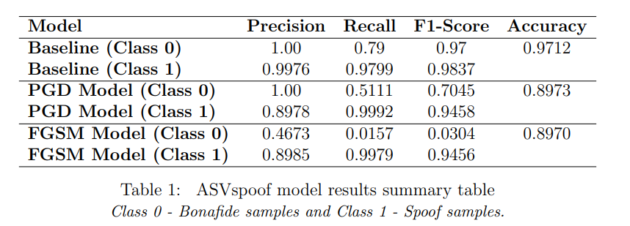
Critical Analysis:
The sensitivity of both lightweight and deep models to FGSM indicates that adversarial vulnerability is not limited to model simplicity. Rather, it reflects fundamental weaknesses in how decision boundaries are learned from spectral features.
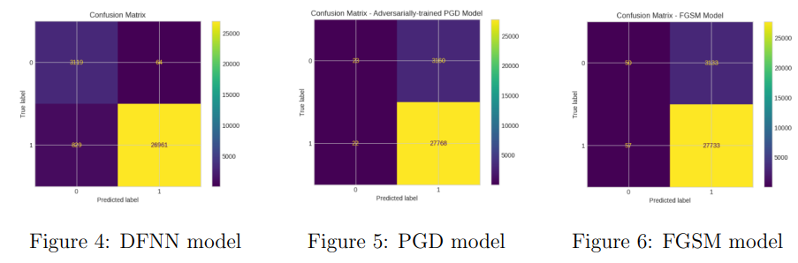
8.3 Impact of PGD Attacks
Overall, all models continuously showed substantial degradation of security performance by Projected Gradient Descent (PGD) attack compared to the Fast Gradient Sign Method (FGSM).
In the lightweight models, moderate amounts of perturbation will create near collapse under these conditions. This resulted in minimal error rate (Equal Error Rate - EER) being close to pure random guessing. , indicating significant limitations in terms of vulnerability due to inability to detect imposters via Voice Biometrics.
PGD exposure to CNNs proved that CNNs were also prone towards PGD vulnerability within this test. In all tests, for example, deeper architectures produced slightly increased levels of PGD resistance at lower perturbations, however, their success was only temporary. All CNN architectures failed when subjected to successive trials or increased strength PGD attacks. These results agree with the findings regarding vulnerability and adversarial robustness of voice biometric systems as published in deep learning literature book published by Madry et al (2018) and JLA and WLA case study on ASVs published by Liu et al (2019) and Wu et al (2020).
Critical Analysis:
PGD exposes worst-case adversarial behaviour, demonstrating that neither architectural complexity nor high baseline accuracy guarantees robustness.
8.4 Lightweight vs CNN-Based Models
A key objective of this study was to compare the adversarial robustness of lightweight and CNN-based spoofing countermeasures. The results show that:
- Lightweight models degrade rapidly under adversarial perturbations
- CNN-based models provide only marginal robustness gains
- Both model types ultimately fail under strong attacks
These findings support the argument that adversarial vulnerability is a systemic issue in learning-based spoofing detection rather than a consequence of insufficient model complexity. While CNNs capture richer spectro-temporal patterns, they remain susceptible to gradient-based manipulation.
8.5 Dataset-Specific Behaviour
Across multiple datasets, patterns of degradation due to adversarial attacks were varied. Specifically, the ASVspoof2019 LA dataset showed a high level of efficacy with adversarial attacks because it is clean and controlled and therefore does not contain natural noise to disguise the perturbations. While the adversarial effects on the WILD dataset tended to be more gradual, indicating the effect of environmental noise and variability in recordings potentially covering up the effects of adversarial perturbations, there were still significant vulnerabilities to PGD-style attacks observed in both datasets. The aforementioned findings suggest that evaluating the robustness of an algorithm based only on benchmark datasets may exaggerate the true robustness of the model when used in a real-world application scenario, and support the need for evaluating algorithms against multiple datasets.
8.6 Security Implications
The False Acceptance Rate (FAR) is a metric that represents the likelihood of falsely accepting a malicious individual as legitimate. As shown by these results, adversarial attacks on models cause an increase in FAR in all datasets, and therefore increase the chances that an individual who has conducted an adversarial attack will be incorrectly accepted into a secure system. This is particularly worrying given that many current ASV deployments are operating in secure locations.
In addition, the above results also demonstrate that simply increasing the accuracy of clean audio will not protect against adversarial attacks. Instead, it is important to build models with robustness in mind and train the models in a way that robust models are built. This is further supported by the defence-oriented studies referenced (Wu et al., 2022; Chen et al., 2022).
8.7 Summary of Findings
The experimental results lead to the following conclusions:
- Both lightweight and CNN-based spoofing countermeasures are highly vulnerable to adversarial attacks
- PGD attacks pose a severe threat, causing near-total performance collapse
- Model complexity does not ensure adversarial robustness
- Dataset characteristics influence observed vulnerability but do not eliminate it
- FAR and EER are more indicative of security risk than accuracy alone
9 Comparison Between Datasets
The behaviour of spoofing countermeasures is compared between the LA (ASVspoof2019) benchmark dataset and the WILD dataset that was collected from real-world recordings. Throughout this section, the difference in how different characteristics of the datasets impact both the baseline performance and vulnerability to adversarial attacks has been analysed to better understand the generalisability of the assessment of how robust a system may be.
9.1 Dataset Characteristics
The ASVspoof2019 LA dataset is an organized baseline for benchmarking countermeasures to detect spoofing using repeated and regulated experimental protocols. The ASVspoof2019 LA dataset includes both high-quality unmodified (clean) audio that is created using well-established algorithms and methods under specific conditions when synthesising spoofed recordings (Kinnunen et al., 2017). Consequently, it has established a framework that allows for reproducibility but also restricts the number of variable acoustic properties.
At the opposite end of the spectrum from the ASVspoof2019 LA dataset is the WILD dataset, which is a group of uncontrolled sample uploads from typical users. The recordings that comprise the WILD dataset are made using many different recording devices, from different environments and atmospheres, and have varying degrees of background noise. Artefacts and variability of the samples in the WILD dataset are significantly greater than those found in the ASVspoof dataset, providing evidence of a more naturalistic deployment setting.
9.2 Baseline Performance Differences
The lightweight models and the CNN-based models achieved a high level of accuracy when tested under controlled conditions with ASVspoof2019 LA. Additionally, while the performance on ASVspoof2019 WILD was either similar or slightly better for the lightweight models, this indicates that artefacts arising in the naturalistic environment that were used to produce the spoofed audio may be easier to detect than artefacts produced in the laboratory from realistic synthesized speech.
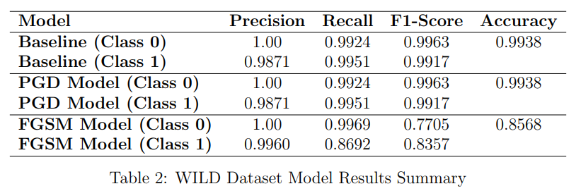
These findings indicate that strong baseline performance on benchmark datasets does not necessarily imply superior real-world effectiveness, as dataset-specific characteristics significantly influence classification difficulty.
9.3 Adversarial Vulnerability Across Datasets
Both datasets experienced adversarial attacks with varying degrees of degradation. Adversarial perturbations have severely affected model performance on ASVspoof2019 LA, especially in the case of FGSM attacks, which have caused rapid degradation in performance. Because the ASVspoof2019 LA dataset has a mostly clean signal without much natural noise, models trained using this dataset are likely to be extremely sensitive to small input variations introduced by adversarial perturbations.
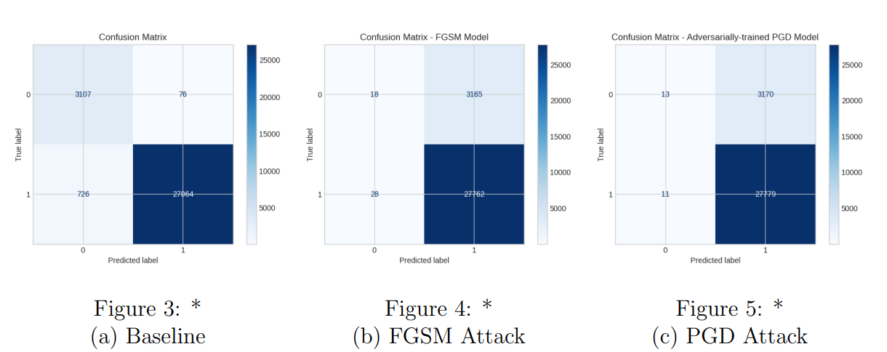
By examining the WILD dataset, it was observed that longer-duration attacks were slow/gradual in nature, particularly when there is a lower level of attack strength. Another potential explanation for this may include the fact that background noise and differences in recording conditions may diminish or eliminate localised distortions introduced by the adversary to diminish the immediate effectiveness of the attack. Therefore, through Imminent Threat of PGD attacks applied to the WILD datasets, there is clear indication of the significant susceptibility of both to adversarial manipulation through an adverse-range attack. Therefore, background noise alone can not be relied upon to protect against adversarial manipulation and has been supported by a number of previous studies demonstrating that these types of attacks will remain effective regardless of the surrounding environmental/ambient noise levels (Liu et al., 2019; Wu et al., 2020).
9.4 Model Behaviour Across Datasets
Lightweight models have greater susceptibility at ASVspoof2019 LA because they are overly responsive to the clean, organized feature distribution. This results in a higher degradation of performance on ASVspoof2019 LA than on the WILD dataset due to the higher susceptibility to imperceptibly perturbing noise.
The CNN model showed some improvement in performance at low perturbation levels, and even failed at high perturbation levels. The WILD dataset had more variability and therefore caused the model to perform differently than the other two datasets. Overall, this data suggests that the robustness and vulnerability of adversarial attacks is affected by dataset characteristics.
9.5 Implications for ASV Evaluation
The dataset comparison highlights several important implications:
- Robustness evaluations conducted exclusively on benchmark datasets may overestimate real-world vulnerability under certain conditions.
- Real-world datasets introduce variability that can both help and hinder adversarial robustness analysis.
- Evaluating countermeasures across multiple datasets is essential for reliable security assessment.
- Dataset diversity should be considered when designing adversarial defences and evaluation protocols.
These findings reinforce the importance of multi-dataset evaluation frameworks when assessing the security of ASV spoofing countermeasures.
9.6 Summary
It has been shown via the data provided in this study that dataset features can significantly impact baseline performance, along with how well or poorly you would perform against adversarial examples. ASVspoof2019 LA serves as a valuable metric to use when conducting a controlled evaluation, however, in order to understand robustness while deployed; it is necessary to utilise real-world datasets such as WILD. In conclusion, the findings of this research demonstrate that an assessment of how resilient an algorithm is to adversarial inputs should include multiple types of settings (e.g., naturalistic). This ensures that we do not incorrectly conclude anything regarding the resilience to adversarial examples based on a small number of comparisons.
10 Discussion and Conclusions
10.1 Discussion
This project was designed to determine how effective spoof detection systems are in resisting against attackers who use adversarial examples. A inexpensive log-Mel frequency based spoof detection model was compared with Convolutional Neural Network (CNN) spoof detection models and it was determined that high initial accuracy on its own does not guarantee that a spoof detection system will resist against adversarial example attacks. Experimental data collected during this research demonstrated that both the log-Mel based model and all CNN spoof detection models also suffer from the adverse effects caused by using adversarial examples. The latter findings corroborate earlier research by Liu et al., (2019) and Wu et al., (2020) demonstrating that when mobile phones are used in conjunction with FGSM and PGD adversarial examples, the false acceptance rate and equal error rate increases, therefore these results support most of the conclusions reached by Liu et al., (2019) and Wu et al., (2020).

It is clear from this research that complex models produce minor improvements in variance when processing undetectable distortions, but they do not provide sufficient barriers against strong iterative adversarial attacks. Overall, this demonstrates that the fundamental nature of being vulnerable to an adversary is indicative of how the models discern between what is true and what is false through the use of acoustic based features.

Finally, as seen in the by analysing the two different recordings, it was clear that the environments where the two recordings were made impact how well the model performs under attack conditions. For example, while variability among the real-world recordings in the WILD dataset produced difficulty determining the smallest distortion, it was noted that regardless of dataset, strong attacks can be performed. This finding demonstrates that a benchmarking dataset alone cannot sufficiently assess the operational security of a given system; rather, multiple disparate datasets need to be combined in order to fully understand the security risks associated with a given deployment of these systems.

Several authors recently published finding or recommendation on robustness enhancement techniques, which included adversarial training and self-supervised learning representations (Wu et al., 2022; Chen et al., 2022). Nevertheless, many of these approaches require additional computation time, which therefore restricts their application in noiseless automatic speaker verification (ASV) implementations. This research indicates that in order to execute a robustness technique, there must be a consistent level of risk vs. benefit in implementing a robustness technique, which also considers the possibility of the extra computation time needed to implement the robustness technique.

10.3 Conclusions
This Thesis systematically studies the adversarial robustness of the countermeasures for voice spoofing. All of the lightweight and CNN-based approaches have been found to be very sensitive and vulnerable to adversarial manipulation.
The summary points below give more detail as to the results of this study.
- Lightweight countermeasures displayed a high-level of adversarial sensitivity, though they performed very well when tested with clean data.
- CNN-based approaches demonstrated little improvement in robustness and failed to be able to survive attacks when an adversary exerted high-level of attack strength.
- While the characteristics of the dataset used played a major part of the observed robustness, this did not eliminate the risk of adversarial manipulation.
- Metrics used to describe Security and Safety such as the False Acceptance Rate and Equal Error Rate are vital in determining the security of voice spoofing countermeasures under real-world conditions.
The most important conclusion of this work is that Adversarial Robustness must be explicitly added to the consideration of countermeasure design and testing for voice spoofing countermeasures.
10.4 Future Work
Future Research Directions should further explore the approach to adversarial defence mechanisms inclusive, but not limited to, adversarial training, feature-smoothing, and ensemble-based approaches. Examining the impact of black-box and Physical World adversarial attacks will further provide improved Threat Modelling. Furthermore, additional pathways for potential deployment and secured Autonomous/Self-Driving Vehicles may be via the incorporation of efficient self-superversed representations and evaluating their Robustness across larger, more diverse, and real-world datasets.
References
Chen, Y., Wang, S., & Liu, X. (2022). Self-supervised learning for robust speech
spoofing detection. IEEE/ACM Transactions on Audio, Speech, and Language Processing, 30. doi: 10.1109/TASLP.2023.3285283
Goodfellow, I. J., Shlens, J., & Szegedy, C. (2015). Explaining and harnessing adversarial examples. International Conference on Learning Representations (ICLR).
Liu, S., Wu, H., Lee, H., & Meng, H. (2019). Adversarial attacks on spoofing countermeasures of automatic speaker verification. IEEE Automatic Speech Recognition
and Understanding Workshop (ASRU).
Madry, A., Makelov, A., Schmidt, L., Tsipras, D., & Vladu, A. (2018). Towards
deep learning models resistant to adversarial attacks. International Conference on
Learning Representations (ICLR)
Cai, Z. (2017). Spoofing countermeasures in automatic speaker verification: A review. IEEE Transactions on Audio, Speech, and Language Processing, 25(12), 2300–2314
H. A. Patil and M. R. Kamble, "A Survey on Replay Attack Detection for Automatic Speaker Verification (ASV) System," 2018 Asia-Pacific Signal and Information Processing Association Annual Summit and Conference (APSIPA ASC), Honolulu, HI, USA, 2018, pp. 1047-1053, doi: 10.23919/APSIPA.2018.8659666. keywords: {Databases;Feature extraction;Task analysis;Convolution;Natural languages;Error analysis;Additives},
Kinnunen, T., & Sahidullah, M. (2017). Automatic Speaker Verification Spoofing and Countermeasures Challenge Evaluation Plan. Computer Speech & Language, 45, 1–18.
Liu, S., Wu, H., Lee, H., & Meng, H. (2019). Adversarial attacks on
spoofing countermeasures of automatic speaker verification. IEEE Transactions on Information Forensics and Security, 14(7), 1800–1815. https://doi.org/10.1109/TIFS.2019.2903763
Panariello, G., Ge, Y., Tak, Y., Todisco, M., & Evans, N. (2023). Malafide: Universal
adversarial attacks against deepfake audio detection. Pattern Recognition Letters,
169, 32–41.
H. Wu, S. Liu, H. Meng and H. -y. Lee, ”Defense Against Adversarial Attacks on
Spoofing Countermeasures of ASV,” ICASSP 2020 - 2020 IEEE International Conference on Acoustics, Speech and Signal Processing (ICASSP), Barcelona, Spain,
2020, pp. 6564-6568, doi: 10.1109/ICASSP40776.2020.9053643.
H. Wu, X. Li, A. T. Liu, Z. Wu, H. Meng and H. -Y. Lee, ”Improving the Adversarial
Robustness for Speaker Verification by Self-Supervised Learning,” in IEEE/ACM
Transactions on Audio, Speech, and Language Processing, vol. 30, pp. 202-217, 2022,
doi: 10.1109/TASLP.2021.3133189.
H. Wu et al., ”Adversarial Sample Detection for Speaker Verification by Neural Vocoders,” ICASSP 2022 - 2022 IEEE International Conference on Acoustics, Speech
and Signal Processing (ICASSP), Singapore, Singapore, 2022, pp. 236-240, doi:
10.1109/ICASSP43922.2022.9746900.

